+999-999-9999

test@gmail.com

123 Anywhere St., Any City

www.bijnorbusiness.com

EDUCATION

SECONDARY SCHOOL

THYNK UNLIMITED HIGH SCHOOL 2011 - 2015

BACHELOR OF TECHNOLOGY

THYNK UNLIMITED UNIVERSITY 2015 - 2017

SKILLS

Web Design

Design Thinking

Wireframe Creation

Front End Coding

MY HOBBY

Playing Basketball

Drawing

Traveling
YOUR NAME
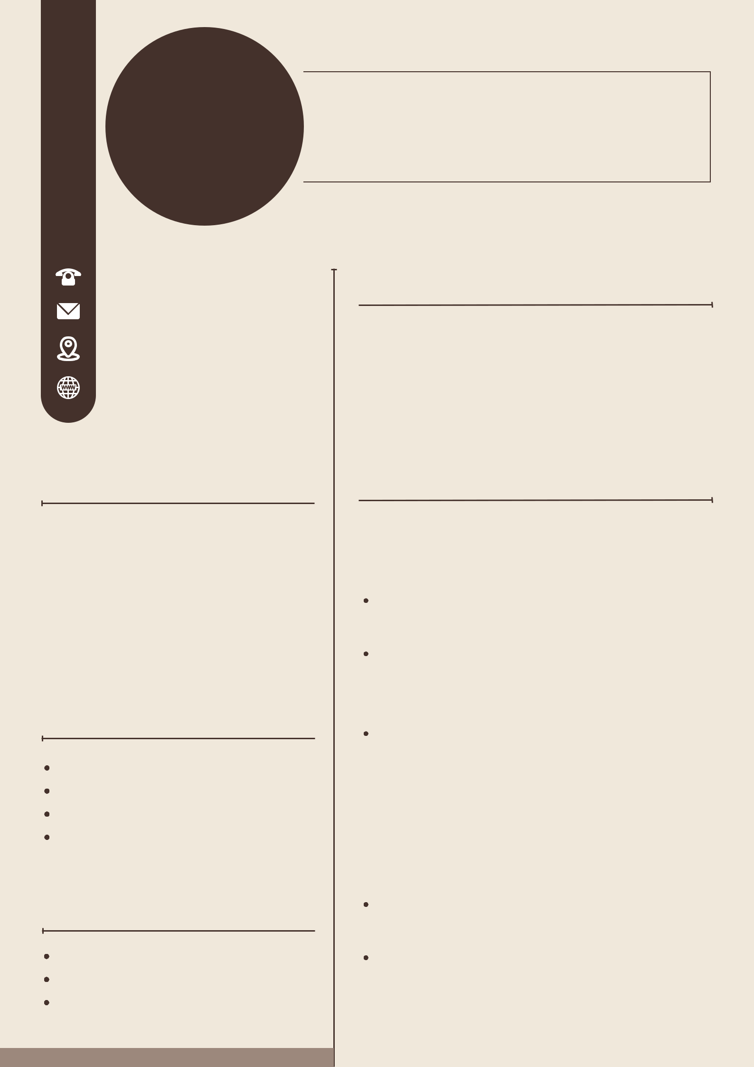

FASHION DESIGNER

ABOUT ME

I am a qualified and professional web developer with five years of experience in database administration and website design. Strong creative and analytical skills. Team player with an eye for detail.

WORK EXPERIENCE

FASHION CREATIVE DIRECTOR

FRADEL AND SPIES CO

2020 - Present

As the Fashion Creative Director, she oversees the entire design process.

The Fashion Creative Director sets the artistic vision and direction for the brand's seasonal collections.

With a keen eye for trends and an innate sense of style, the Fashion Creative Director oversees the entire creative process

LEAD FASHION DESIGNER

LICERIA & CO.

2017 - 2020

As the Fashion Creative Director, she oversees the entire design process. The Fashion Creative Director sets the artistic vision and direction for the brand's seasonal collections.

