About Me

Lorem ipsum dolor sit amet, consectetur adipiscing elit. Vestibulum sit amet quam rhoncus, egestas dui eget, malesuada justo. Ut aliquam augue dui.

+9999999999

test@gmail.com

Najibabad, Bijnor

Language

English

Germany (basic)

Spain (basic)

Expertise

Management Skills

Creativity

Digital Marketing

Negotiation

Critical Thinking

Leadership

YOUR NAME
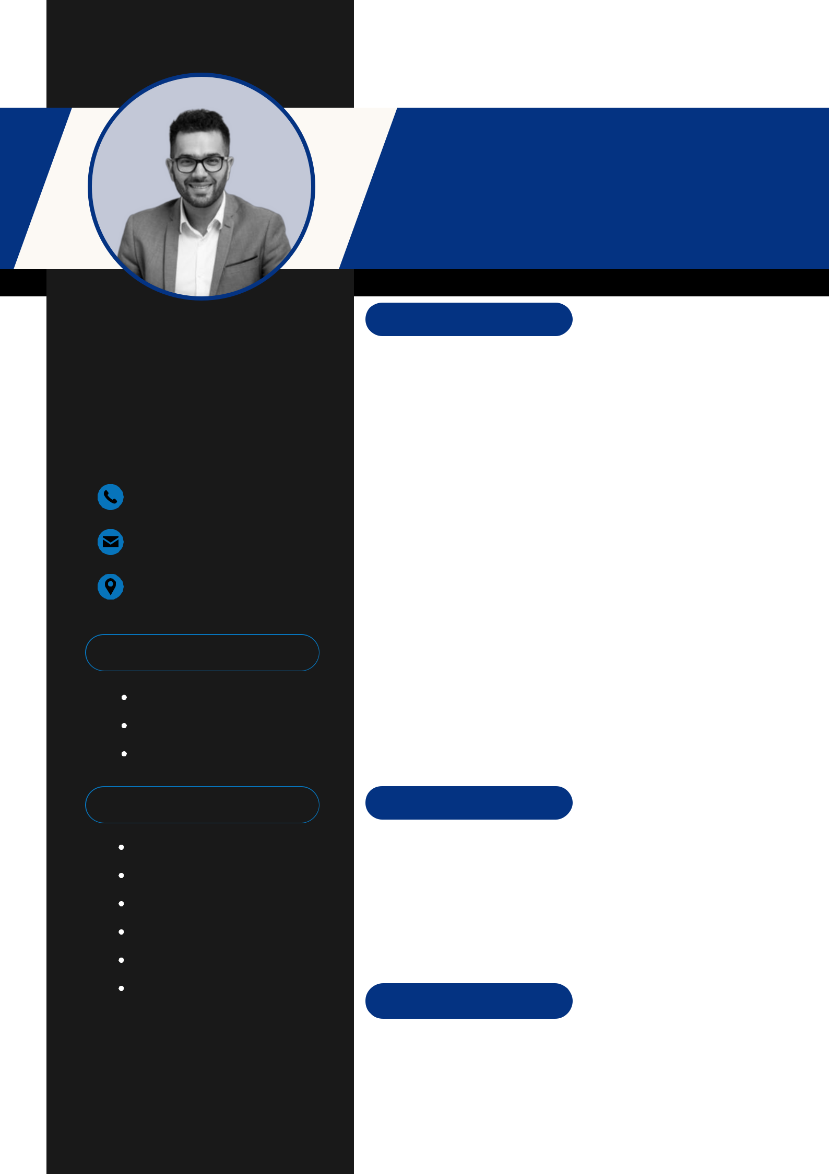

Product Designer

Experience

Arowwai Industries

Sydney - Australia

2020 - 2022

Lorem ipsum dolor sit amet, consectetur adipiscing elit. Vestibulum sit amet quam rhoncus, egestas dui eget, malesuada justo. Ut aliquam augue.

Wardiere Inc.

Sydney - Australia

2016 - 2020

Lorem ipsum dolor sit amet, consectetur adipiscing elit. Vestibulum sit amet quam rhoncus, egestas dui eget, malesuada justo. Ut aliquam augue.

Studio Showde

Sydney - Australia

2010 - 2015

Lorem ipsum dolor sit amet, consectetur adipiscing elit. Vestibulum sit amet quam rhoncus, egestas dui eget, malesuada justo. Ut aliquam augue.

Education

Borcelle University

Bachelor of Business Management

2014 - 2023

Borcelle University

Master of Business Management

2014 - 2018

Skills Summary

Design Process

Project Management

78 %

81 %

